


Supervisor Reviewer Guide
Conflict of Interest Disclosures

Table of Contents

CONFLICTS OF INTEREST – Disclosure Review Process

A. Overview of Supervisor Steps:
1. Access the System and View Employee Disclosures 3
2. Evaluate a Disclosure 5
3. Case Documentation 7
3.1. Case Review Tab 7
3.2. COI Determination: No Further Action Required 8
3.3. COI Determination: Action Items Required-No Management Plan 10
3.4. COI Determination: Management Plan Required 12
3.5. COI Determination: Request Additional Info From Discloser 15

B. Overview of Senior Reviewer Steps (i.e., Dean or VP)………………………………………………………………………………………………….16
1. Responsibility
2. Review Cases Sent by Primary Reviewer (i.e., Dept Chair or Director)
3. Notify Primary Reviewer of your Concurrence, or Request for Further Information, Analysis, etc.

C. How To……………………………………..………………………………………………………………………………………………………………..………………17
1. Send Notification

CONFLICTS OF INTEREST – DISCLOSURE Review Process

A. Overview of Supervisor (PRimary Reviewer) Steps:
- Access the System and View Employee Disclosures
- Evaluate a Disclosure and Create a Case for Reported Conflicts
- Case Review and Determination

1. Access the System and View Employee Disclosures
1.1 As a supervisor (Primary Reviewer), you will receive an email notification informing you that a disclosure requires your attention in the system whenever one of your employees submits a disclosure form.
To access the system, go to the link provided in the email and log in with your JAG Number. This will bring you to your COI RiskManager Home page.
1.2. To view the disclosures that require your review, click on Review Disclosures on the left navigation pane. This will bring you to the Review Disclosures Page.
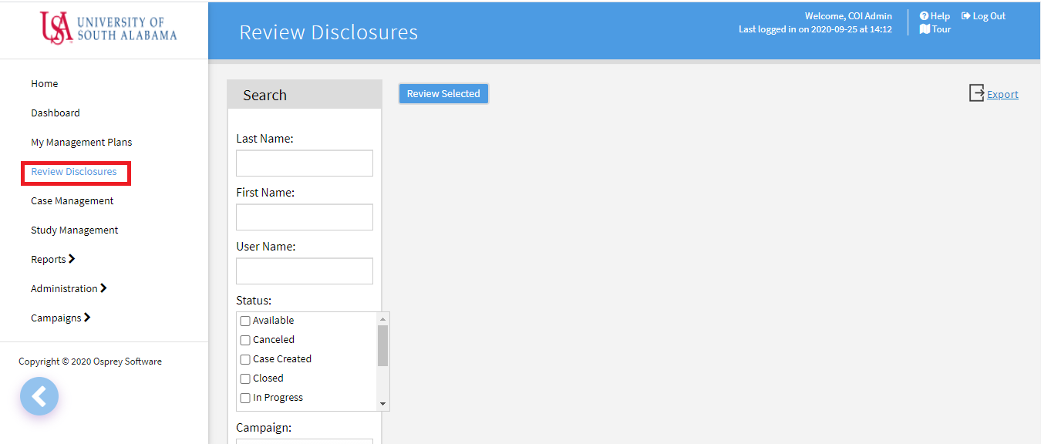
1.3. Using the Search pane on the left of the page, select the Submitted option in the dropdown selection under Status, then select COI 2021 (or current year) from the Campaign drop down menu. Then hit Search. Note: to view status of all your direct reports (who are assigned the annual COI Disclosure form), select the Case Created, In Progress, Reviewed, Start and Submitted Status options.
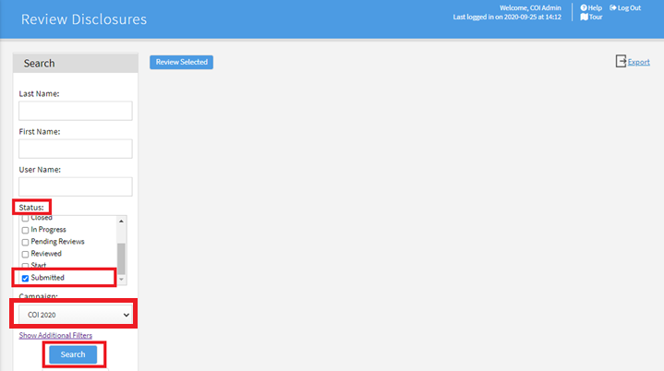
The results page shows a list of disclosures with information such as name of the participant, a flag for disclosures that contain conflicts, list of potential conflicts, relevant dates, etc.
1.4. To view a disclosure, click on the form icon. This will bring you to the View Form page where you can see the disclosure.
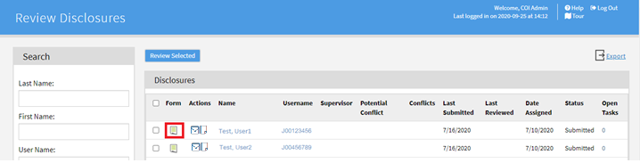
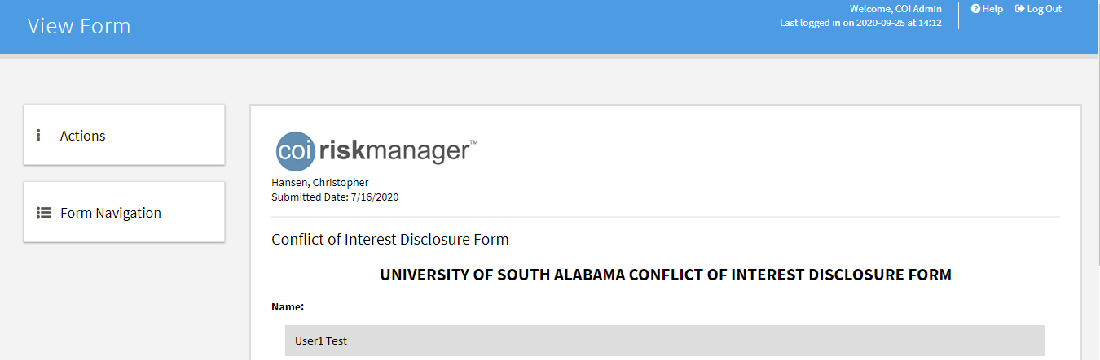

2. Evaluate a Disclosure
2.1. If all responses are “no,” or if there are no conflicts reported on the disclosure, go to the Actions menu and click Mark as Reviewed. The annual COI Disclosure submission and review cycle for this employee is now complete.
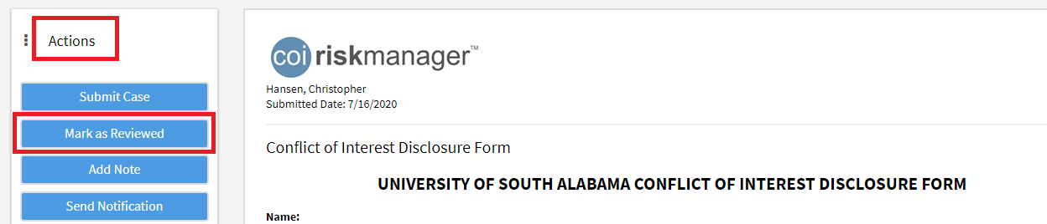
2.2. If “yes” answers are reported on the form, review the disclosed information to determine whether a conflict exists (actual, potential or perceived) and/or if any mitigating measures are necessary. Potential conflicts will be highlighted in yellow.
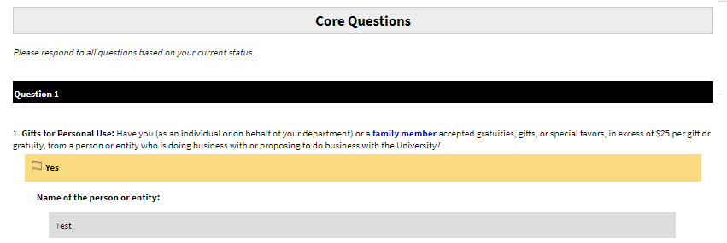

2.3. Go to the Actions menu and click Submit Case to begin documenting your assessment.
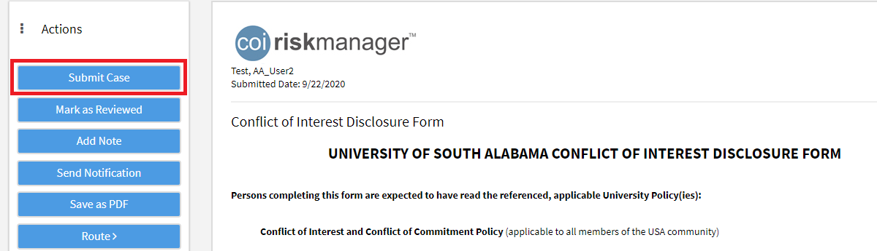
2.4. Check Create New Disclosure Level Case in the pop-up box and click Create Case(s).
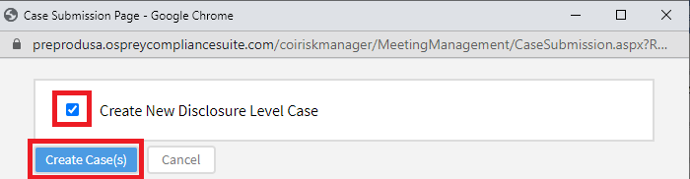
A system message will appear with the Case ID # which you will need for the next step; click OK.
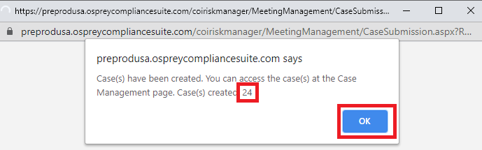
2.5. To access the case, go to the Case Management page (left-screen menu). Use the Search pane on the left to search on the Case ID # or discloser’s name (or, scroll down your log of all Cases to the right, to the Case # you are seeking). Click on the Case ID # to access the case.
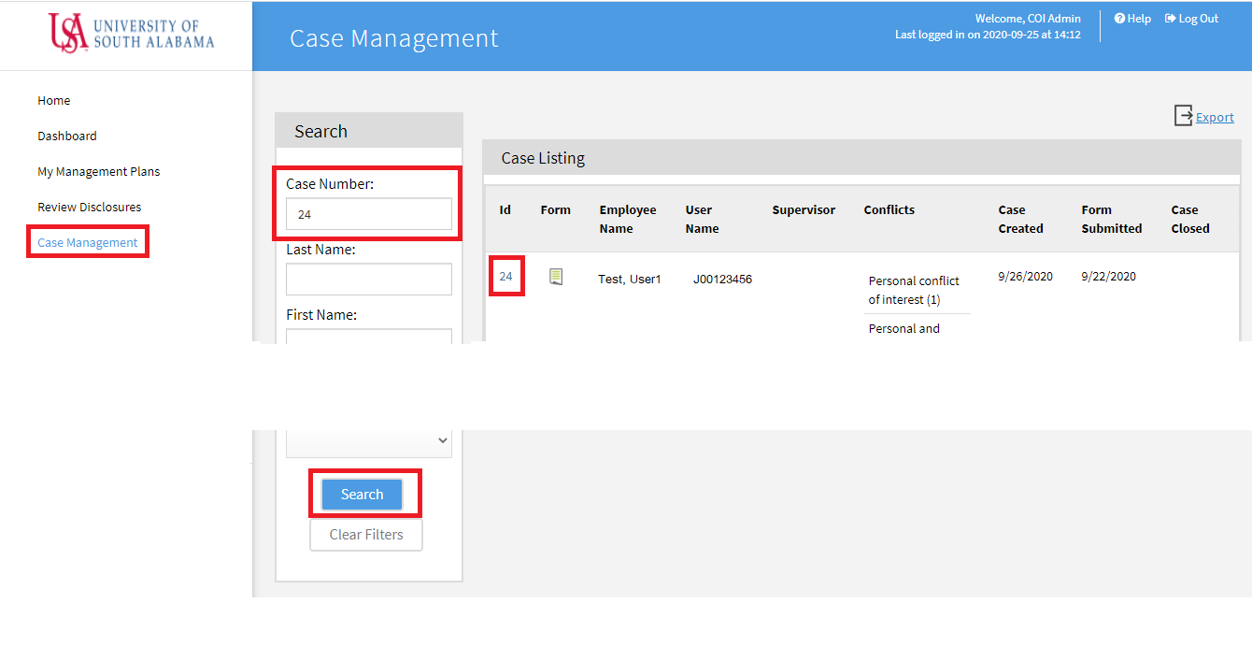

3. Case Documentation

3.1. Case Review Tab

In the open case, go to the Review tab, click Edit.
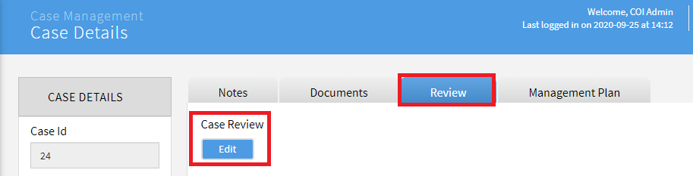
Record your initial assessment of the reported conflicts in the following fields (skip over the shaded “Flagged Responses” section which may only show a portion of the submitter’s responses):
- Policy Compliance – Select whether or not the disclosed conflicts are consistent with USA’s Conflict of Interest and Conflict of Commitment Policy or other related policies (as applicable).
- Institutional Responsibilities – Select whether or not the disclosed conflicts will interfere with the individual’s USA responsibilities.
- COI Disclosure Determination – Select the response that best represents your assessment of the conflicts.
- Rationale for Determination – Provide further explanation of your assessment in the text box.
- Comments/Recommended Actions (if applicable) – Use this to document required action items (if any) or other information about this case.
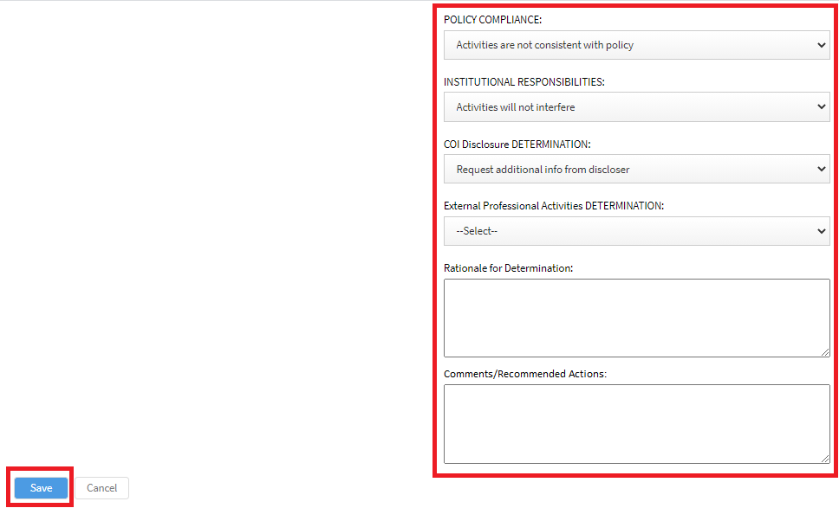
Click Save to save your responses to the questions on the Review tab. See the next sections for guidance on steps to take for each type of COI Disclosure Determination.

3.2. COI Determination: No Further Action Required

3.2.1. Confirm that your reasons are documented in the Rationale for Determination field. Then click Close Case.
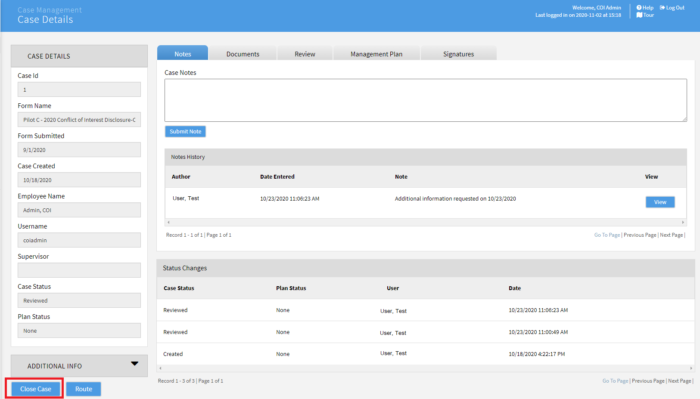
3.2.2. Scroll down to Related Forms and click on the form icon to open the most recent version of the disclosure.
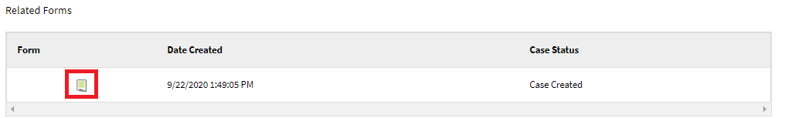

3.2.3. In the open form click Actions and then click Mark as Reviewed. The annual COI Disclosure submission and review cycle for this employee is now complete.
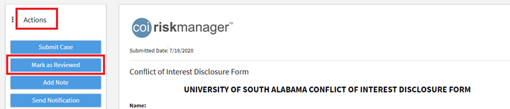

3.3. COI Determination: Action Items Required-No Management Plan

3.3.1. Confirm that the required action items are documented in the Comments/Recommended Actions field, and that your reasons are documented in the Rationale for Determination field.
3.3.2. Route the case to your supervisor (Secondary Reviewer) to share your recommendations. To do this:
- Click Route

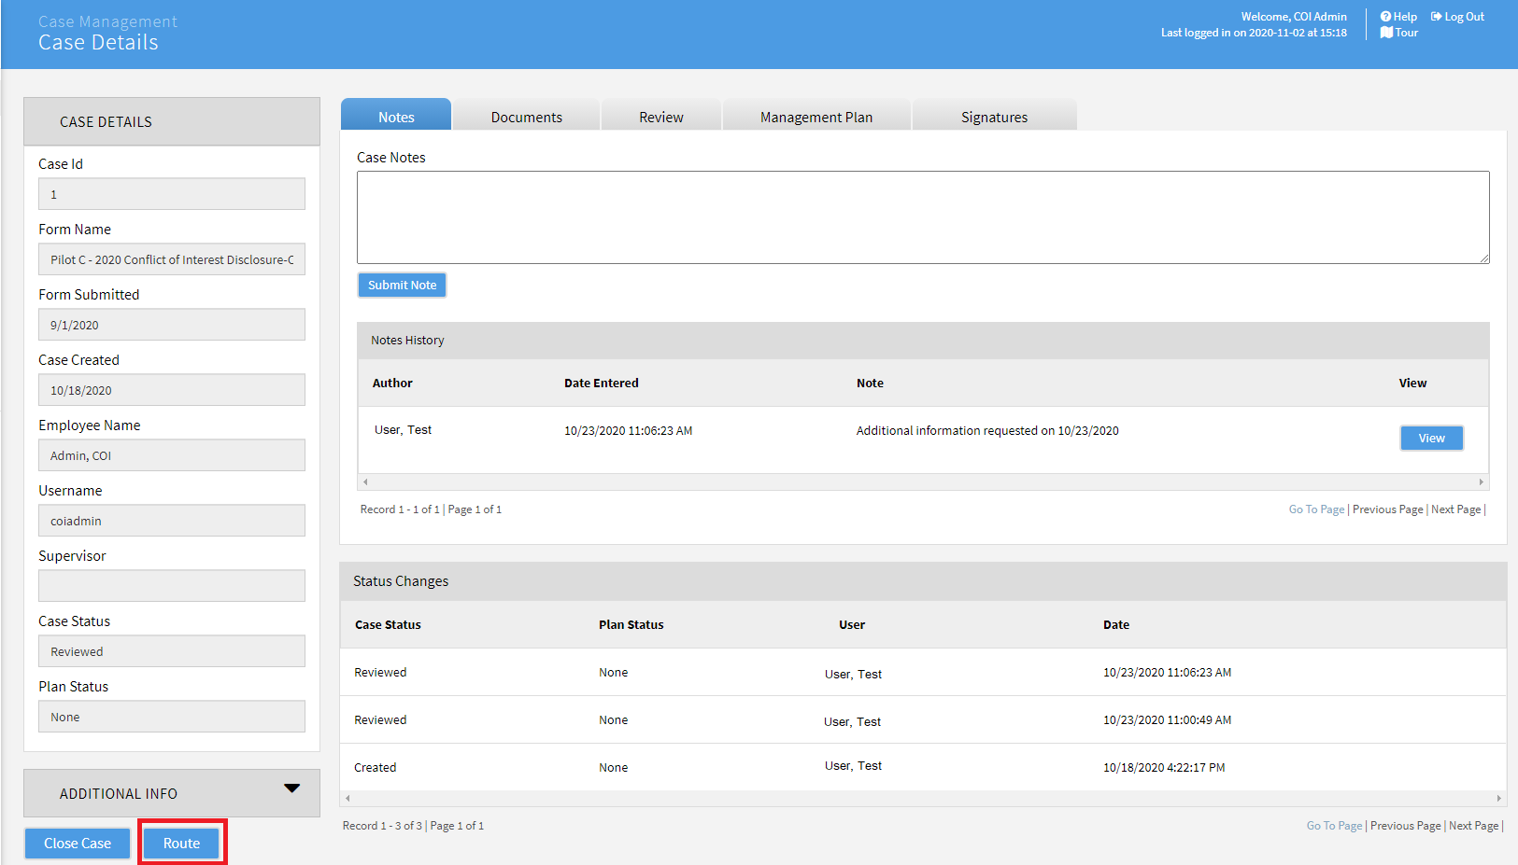

- Select your supervisor’s name from the Route To: dropdown and fill out the Reason: field and Comments box if necessary (example: “please review my recommended actions for this case”). Click OK. This will send a notification to the individual selected in the Route To: field. The notification will contain instructions for logging into COI and updating the case.
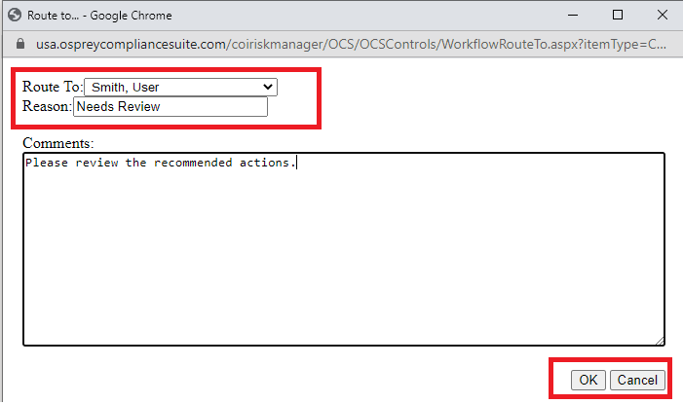
3.3.3. After the case is updated and you and your supervisor agree over the Recommended Actions for the discloser, send a notification to the discloser informing them of the recommended actions. Please see Send Notification (last section of this Reviewer Guide) for details of these steps.
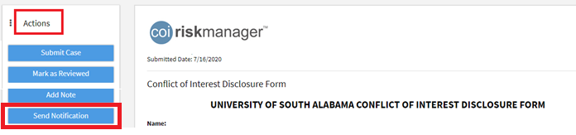
3.3.4. After you receive the discloser’s agreement with the required action items (such as an email response or other electronic file), return to Case Management, click the applicable case number, and attach the document to the case in the Documents tab in the case. To do this:
- Go to the Documents tab and click Add Document:
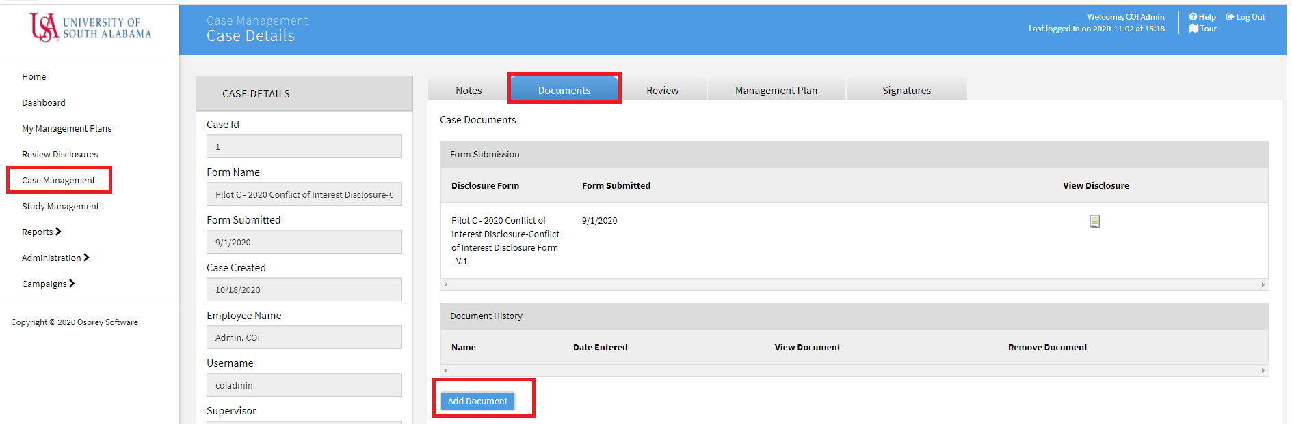
- Click Choose file on the Case Document page to browse for the file to be attached. Click Save when finished.
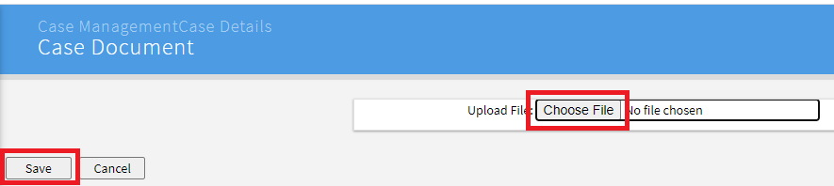
3.3.5. The annual COI Disclosure submission and review cycle for this employee is now complete. A periodic review of the assigned action steps is recommended, to assure sustained compliance.

3.4. COI Determination: Management Plan Required

3.4.1. Confirm that your reasons are documented in the Rationale for Determination field.
3.4.2. Go to the Management Plan tab and select MANAGEMENT PLAN INSTRUCTIONS in the Template Name dropdown menu (Resolution section) for instructions on creating a proposed management plan.
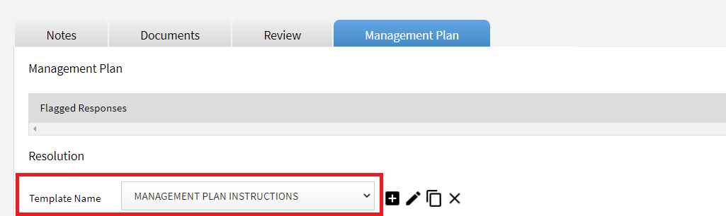
3.4.3. When you have selected the applicable Management Plan template and tailored it to address the specific conflict(s), return to the case and upload it as a Word document under the Documents tab.
In the Documents tab:
- Click Add Document:
- Click Choose file on the Case Document page to browse for the file to be attached. Click Save when finished.
3.4.4. Click Route to notify your supervisor that the case, with attached Management Plan, is awaiting review.
- Click Route

- Select the supervisor’s name from the Route To: dropdown and fill out the Reason: field, and provide necessary instructions in the Comments box. Click OK. This will result in an email notification to the individual selected in the Route To: field. The notification should essentially instruct the recipient to log-in to COI Risk Manager and review the submitter’s COI Disclosure form, along with your proposed Management Plan document.
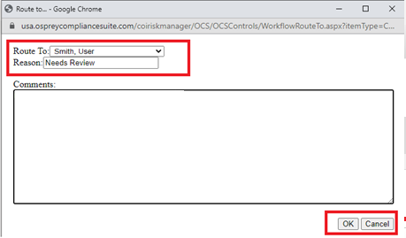
3.4.5. Await notification from your supervisor (e.g., Senior/Secondary Reviewer, typically a Dean, VP, or other senior administrator). If they are in agreement with your recommended Management Plan, follow the steps in section C.1. (“How To”), “Send A Notification,” to notify the discloser of the Management Plan (similar to steps in sections 3.3.3 & 3.3.4, above). Instruct the discloser to download the plan, print, sign to indicate their agreement with the Management Plan, scan, save as pdf file, then return to you. The discloser can either upload it to the case (log-in, click Home on the menu, click Show Disclosures Available to Update, click the Update button next to your current COI Disclosure form, scroll down to the very bottom of your form, and click Yes to the question, “Do you have supporting documentation to attach to your disclosure?” and follow instructions to upload the file), or email it to you to upload. A finalized Management Plan should have both discloser and your signatures).
- If your supervisor (second-level reviewer) proposes edits to the plan or another course of action, be sure to document a final agreement between the two of you by updating the Comments box in the Review section of the Case (the Notes feature in the Case can also be used to summarize the communications between you and the second-level reviewer), and/or upload a final version of the Management Plan.
3.4.6. Upon completion of uploading the signed version of the Management Plan as a pdf file, the annual COI Disclosure submission and review cycle for this employee is now complete. A periodic review of the Management Plan should be performed to assure sustained compliance.

3.5. COI Determination: Request Additional Info From Discloser

3.5.1. To request additional information from the discloser before making a determination, scroll down to Related Forms (while still in the Case Review tab) and click on the form icon to open the most recent version of the disclosure.
3.5.2. In the open form click Actions and then Send Notification to send a notification to the discloser.
See Send a Notification for detailed instructions on the next steps.

B. Overview of SENIOR REVIEWER Steps:
1. Introduction: A Senior/Secondary Reviewer (supervisor of the Primary Reviewer) would typically only need to be involved in a faculty or employee’s COI Disclosure if disclosed information is determined by the Primary Reviewer to be a potential, perceived or actual conflict of interest. If the primary reviewer approves a COI Disclosure on the condition that recommended actions are met, concurrence by the Senior/Secondary Reviewer is optional. However, for approvals determined to need a Management Plan, concurrence by the Senior/Secondary Reviewer will be required.
2. To Review Cases Routed by the Primary Reviewer (e.g., Dept Chair or Director):
- The Senior/Secondary Reviewer receives a notification via email when a Case has been routed for their attention;
- Log-in to COI Risk Manager, and click the folder icon in the Tasks to Complete section (in your Home menu) to go to the Case;
- Click the Review tab from the menu across the upper part of your screen, then scroll down beyond the Flagged Responses section to where the primary reviewer entered their determinations (including Rationale for Determination and Comments);
- To review the submitter’s COI Disclosure form while still in the Case Review tab, scroll down to Related Forms and click the document icon to view the most recent version;
- Upon review of the form and the primary reviewer’s assessment (you can return to the primary reviewer’s assessment by going back to Home, click the folder icon in the Tasks to Complete section again, click the Review tab, then scroll down), determine whether you are in agreement;
- Document your decision by clicking the Notes tab in the Case (from the menu across upper part of your screen). Enter your note in the text box, then click Submit Note.
3. Notify Primary Reviewer of your Concurrence, or Request for Further Information, Analysis, etc.
a. If the Primary Reviewer recommended, “Approved with Required Actions,” you may:
- click the Review tab in the Case and scroll down to the Related Forms section;
- click on the document icon of the submitter’s COI Disclosure form;
- click Actions, then the Send Notification button. To send to the Primary Reviewer, you must change the default User by selecting Supervisor in the To: option;
- Enter a subject;
- Select the Adhoc Notification Template from the Notification Type dropdown menu;
- Prepare your message in the Body text box (either that you concur with recommended actions, or need to modify them), then click Send Mail;
- You also have the option of sending to the original submitter by selecting User in the To: option (in which case, the Primary Reviewer’s email is included as a default cc:). The notification should direct their attention to your note.
b. If the Primary Reviewer recommends, “Approved with Management Plan,” you may:
- click the Documents tab in the Case menu across your upper screen;
- look down to the Document History section and click the document icon to review the Management Plan submitted by the Primary Reviewer;
- To either concur with the Management Plan or request an edit, document your decision using the Notes tab as in step 2 (last bullet) above, then notify the Primary Reviewer either by phone, email, or the Send Notification feature (step a, 3rd bullet, above). You may also upload an edited version of the Management Plan in the Documents tab of the Case (use Add Document).
c. If additional information is needed from the submitter, either the Primary or Secondary Reviewer can use the Send Notification feature to request it. Follow steps in C.1 and C.2, below.
Note: When using the Send Notification feature, the default recipient is User which is the original submitter of the COI Disclosure form. In this instance, the submitter’s supervisor (Primary Reviewer) email address will auto-appear in the cc: line. Additional email addresses can be included if necessary. Changing the recipient to Supervisor will automatically route your message to the submitter’s supervisor (Primary Reviewer).

C. How To…

Send a Notification
- From within the COI Disclosure form, click on Actions and then Send Notification:
- In the Notification window select the following fields:

- To: Check that User is selected if your intended recipient is the discloser, or Supervisor if your intended recipient is the Primary Reviewer (submitter’s supervisor). You may cc: additional recipients if necessary by entering their email addresses, for instance the email of the Secondary Reviewer (Supervisor is always a default cc).

- Notification Type: Select the template for the type of communication you want to send to the user:

  - Additional Information Needed – For requesting additional information from the discloser before making a final determination.
  - Management Plan – provides general instructions to Primary Reviewer, Secondary Reviewer and Submitter roles.
  - Adhoc Notification Template – blank slate for drafting your own message
  - Campaign Start Notification – for re-sending in case an employee missed the original notification
  - User Added to Campaign – for re-sending in case an employee missed the original notification.

- Body: You can edit the default message text to fit your needs based on what you need from the recipient. Note: if [[FirstName]] [[LastName]] appear in the pre-prepared Body, they are placeholders that will automatically populate the notification with the discloser’s name when it is sent.
Click Send Mail when you are ready to send the notification.
