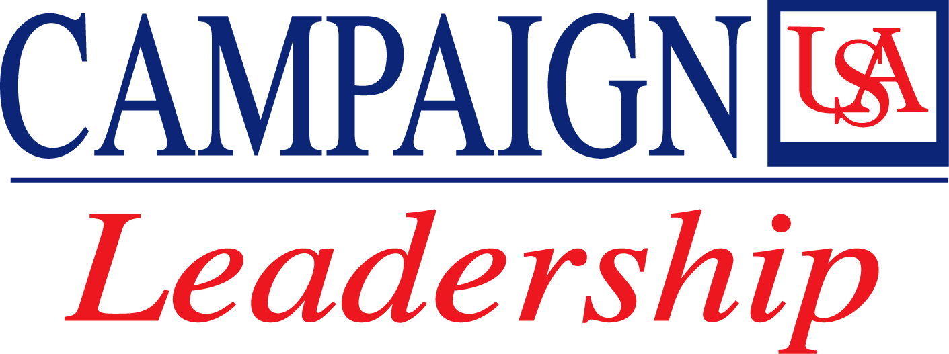

Contact: Jennifer Z. Ekman
jekman@usouthal.edu
(251) 460-6360

Campaign USA Chairman Makes $500,000 Gift to
Football Field House

Area to be named “Jim and Frances Yance Coaches Suite”

University of South Alabama Campaign USA Chairman Jim Yance and his wife, Frances, have made a $500,000 gift to the new football field house. Yance, a 1970 graduate, also serves as vice chairman of the USA Board of Trustees.

The “Jim and Frances Yance Coaches Suite” will include the main foyer entrance, the head coach’s office and conference room, reception and administrative offices.

The Yance gift is the first fund-raising gift and naming opportunity for the field house, and the largest gift to date to the new football program. This brings the Yances’ total giving to the University over time to $619,000.

“From the beginning, implementation of the football and marching band programs has been contingent upon strong support from the University’s friends and philanthropists,” said USA President Gordon Moulton. “We are especially appreciative of Jim and Frances Yance, as their generous gift is important in successfully implementing our facilities plan for the new Jaguar football program. Further, we know that gifts like this inspire others to give as well.”

In addition to the $500,000 gift, the Yances also have contributed $50,000 to the USA Football Support Club and $15,000 to the campus Alumni Bell Tower project. The University matched the Bell Tower gift with $7,500. They also recently increased their gifts to the James A. Yance Endowed Scholarship for Pre-Law Students, which was established in 2004. To date, the Yances have contributed $22,000 to the scholarship fund, which has been matched dollar-for-dollar by the University for a total endowment of $44,000.
“As an alumnus, I have been directly and deeply touched by the University. My USA education and participation in USA athletics have been a significant part of the foundation for every positive experience and accomplishment in my life,” Jim Yance said. “The football program will significantly enhance the college experience for USA students in the future. Frances and I are happy to support it.”

Frances Yance said, “I am thrilled that our gift will mark the beginning of the new football field house. In our home, I hung a picture of Jim holding his 1967 award for ‘Outstanding Athlete of the Year.’ Obviously, the new field house holds great personal meaning for me. We are both very proud to support Campaign USA and especially the new football program.”

Athletic Director Joe Gottfried said, “As an outstanding athlete and student, Jim had a wonderful experience at USA. He has always been an active alumnus and played a major role in helping to select the new football coach Joey Jones. This is a proud day, because we have one of our own supporting this University. Jim has been a driving force for USA.”

Head Football Coach Joey Jones said of the gift to the football program, “I have been inspired by the commitment of the USA President and Board of Trustees to do things in a first-class way regarding this football program, and the new field house will be one example. It makes me feel good as a coach, because without private contributions, we can’t meet our goals. I would like to thank Jim and Frances for their contribution.”

USA Vice President of Development and Alumni Relations Dr. Joseph F. Busta, Jr., said, “This gift from Frances and Jim is both a milestone gift for our new football program and for Campaign USA, on which Jim has worked tirelessly since the beginning. It’s clear he was the perfect man to lead this campaign.”

Located on the northwest corner of campus, the football field house will include weight rooms, training rooms, locker rooms, team meeting rooms and coaches' offices. It will overlook the football practice fields.

The Yance gift is part of Campaign USA, the University’s first comprehensive fund-raising campaign that seeks to raise $75 million for USA programs, faculty, students and construction over three years. Campaign USA was launched in March 2006 and, to date, has raised $69.8 million. Led by Yance, the Campaign USA Leadership team is comprised of local civic, business and national leaders, many of whom are alumni.

Campaign USA will enrich all aspects of USA, from its academic colleges and schools to its hospitals, athletic programs, libraries and campuses. The money raised will be used to fund such items as undergraduate and graduate scholarships, professorships, classroom and laboratory equipment, and health care innovations. Funds will also be used for capital enhancements to USA’s athletic facilities and a campus bell tower.

For information on Campaign USA, visit www.campaignusaleadership.com or call (251) 460-7032.

The University of South Alabama

Since its founding in 1963, the University of South Alabama has been one of Alabama’s fastest growing universities, currently enrolling more than 14,000 students in a wide range of academic programs in Allied Health Professions, Arts and Sciences, Mitchell College of Business, Computer and Information Sciences, Continuing Education and Special Programs, Education, Engineering, Medicine, Nursing and Pharmacy. The University has awarded 62,000 degrees.

In addition to teaching and research, USA is one of the largest health care providers in the Mobile region, with its faculty physicians and two hospitals – Children’s & Women’s and USA Medical Center – involved in more than a quarter million patient encounters annually.
# 30 #

